School of Education & Human Services
2017 Student Teacher Survey Summary

When will you receive your diploma from Canisius College?
Spring 2017 | 88.% | 22
Summer 2017 | 12% | 3
Fall 2017 | 0.0% | 0
Total | 100% | 25
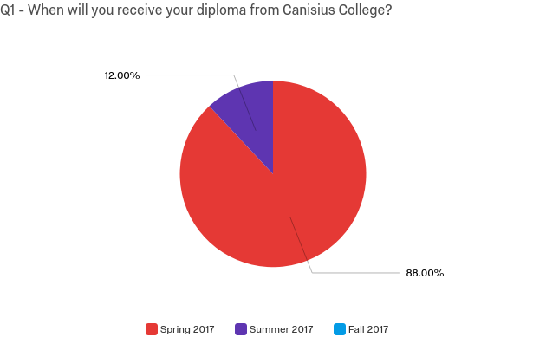

What is your Program at Canisius?

Undergraduate Adolescence Education | 24% | 6
Undergraduate Early Childhood/Childhood Education | 12% | 3
Undergraduate Physical Education / Health Education | 4% | 1
Undergraduate Childhood Special Education | 36% | 9
Deaf Education | 12% | 3
Graduate Physical Education | 12% | 3
Total | 100% | 25

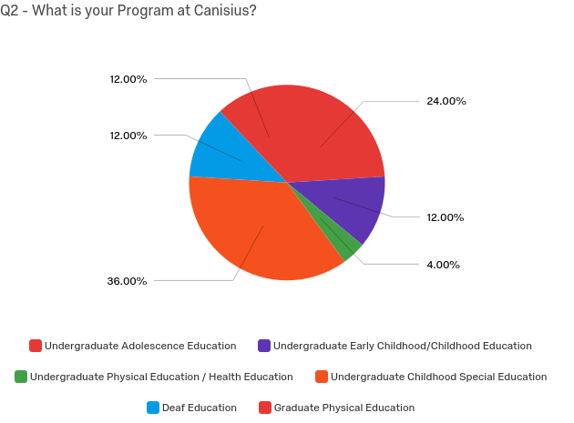

Based on my preparation at Canisius College, I understand learning, teaching and/or other professional theoretical foundations.

Strongly agree | 80% | 20
Somewhat agree | 20% | 5
Neither agree nor disagree | 0.% | 0
Somewhat disagree | 0% | 0
Strongly disagree | 0% | 0
Total | 100% | 25

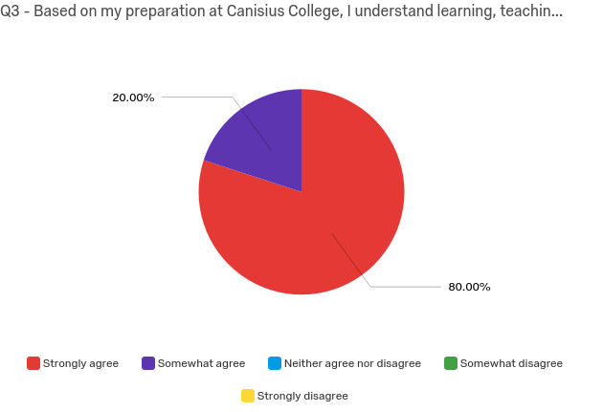

Based on my preparation at Canisius College I can apply best practices in my profession.

Strongly agree | 88% | 22
Somewhat agree | 12% | 3
Neither agree nor disagree | 0% | 0
Somewhat disagree | 0% | 0
Strongly disagree | 0% | 0
Total | 100% | 25

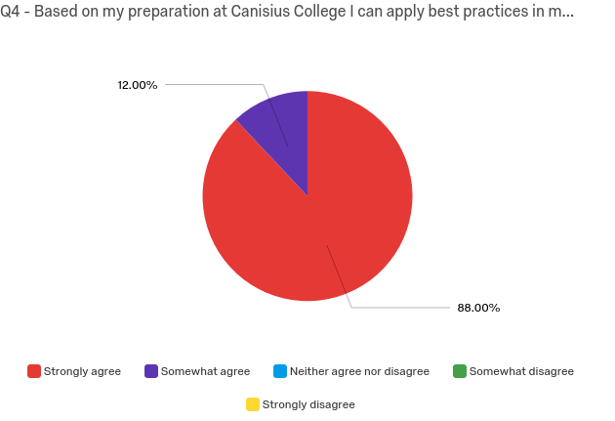

Based on my preparation at Canisius College I can maintain appropriate classroom management.

Strongly agree | 68% | 17
Somewhat agree | 28% | 7
Neither agree nor disagree | 4% | 1
Somewhat disagree | 0% | 0
Strongly disagree | 0% | 0
Total | 100% | 25

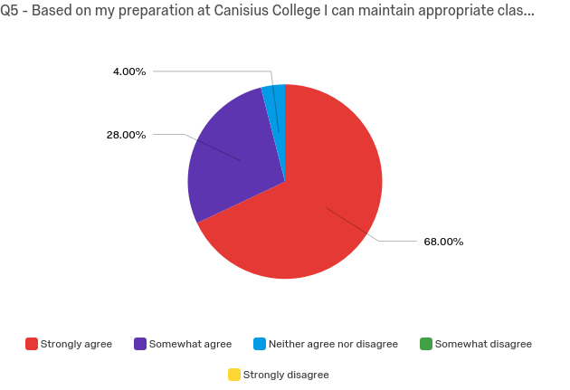

I am able to employ strong knowledge in my content area.

Strongly agree | 88% | 22
Somewhat agree | 12% | 3
Neither agree nor disagree | 0% | 0
Somewhat disagree | 0% | 0
Strongly disagree | 0% | 0
Total | 100% | 25

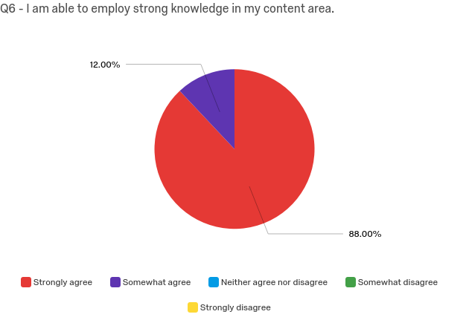

I am able to employ appropriate pedagogical content knowledge.

Strongly agree | 88% | 22
Somewhat agree | 12% | 3
Neither agree nor disagree | 0% | 0
Somewhat disagree | 0% | 0
Strongly disagree | 0% | 0
Total | 100% | 25

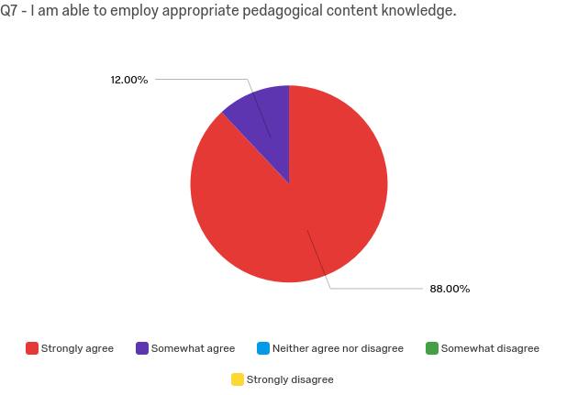

Based on my preparation at Canisius College I am able to achieve positive outcomes regarding student learning, achievement and/or development.

Strongly agree | 96% | 24
Somewhat agree | 4% | 1
Neither agree nor disagree | 0% | 0
Somewhat disagree | 0% | 0
Strongly disagree | 0% | 0
Total | 100% | 25

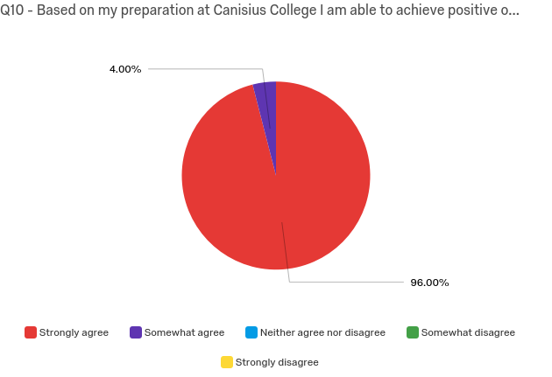

Based on my preparation at Canisius College I can set clear learning goals and align instruction with standard based content.

Strongly agree | 96% | 24
Somewhat agree | 4% | 1
Neither agree nor disagree | 0% | 0
Somewhat disagree | 0% | 0
Strongly disagree | 0% | 0
Total | 100% | 25

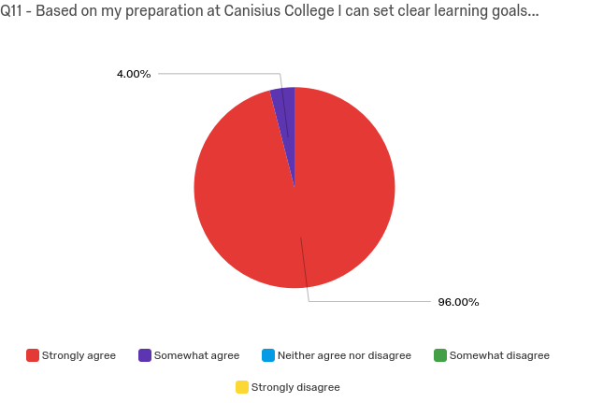

Based on my preparation at Canisius College I can engage and motivate students.

Strongly agree | 96% | 24
Somewhat agree | 4% | 1
Neither agree nor disagree | 0% | 0
Somewhat disagree | 0% | 0
Strongly disagree | 0% | 0
Total | 100% | 25

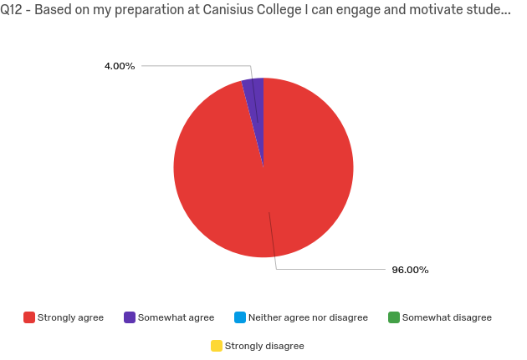

I am able to successfully consider multiple ability levels in diverse P-12 settings when developing lessons and assessments.

Strongly agree | 76% | 19
Somewhat agree | 24% | 6
Neither agree nor disagree | 0% | 0
Somewhat disagree | 0% | 0
Strongly disagree | 0% | 0
Total | 100% | 25

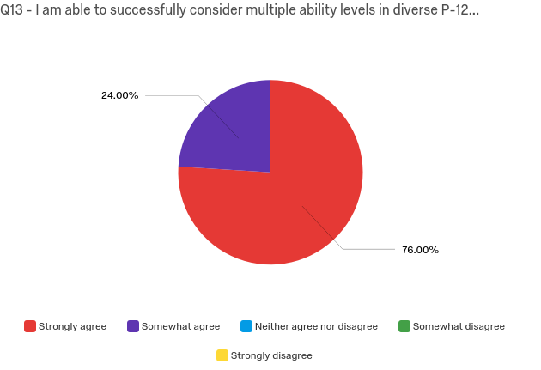

My experience at Canisius College has enabled me to effectively teach diverse P-12 student populations.

Strongly agree | 76% | 19
Somewhat agree | 16% | 4
Neither agree nor disagree | 4% | 1
Somewhat disagree | 4% | 1
Strongly disagree | 0% | 0
Total | 100% | 25

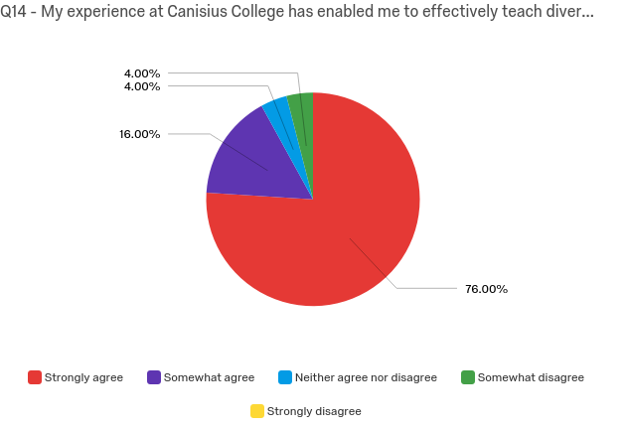

I am willing and able to use the results of P-12 assessments of student learning to guide my instruction and/or professional effectiveness.

Strongly agree | 83% | 20
Somewhat agree | 17% | 4
Neither agree nor disagree | 0.% | 0
Somewhat disagree | 0.% | 0
Strongly disagree | 0% | 0
Total | 100% | 24

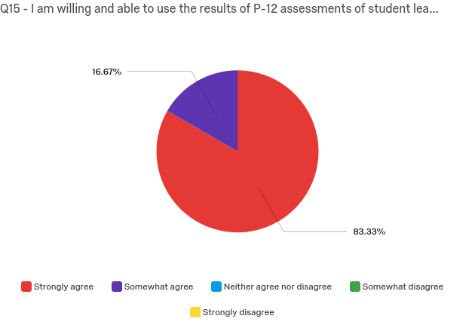

I am willing and able to engage in collaboration to augment my professional practice.

Strongly agree | 92% | 23
Somewhat agree | 8% | 2
Neither agree nor disagree | 0% | 0
Somewhat disagree | 0% | 0
Strongly disagree | 0% | 0
Total | 100% | 25

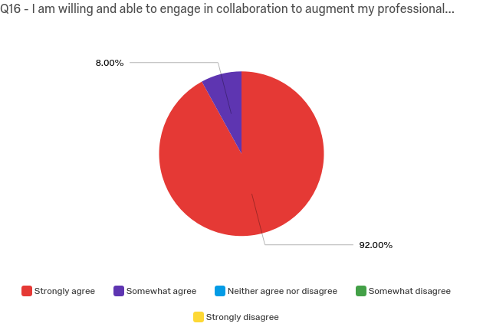

After graduating, I plan to assume appropriate leadership/roles in the school and/or district.

Strongly agree | 76% | 19
Somewhat agree | 24% | 6
Neither agree nor disagree | 0% | 0
Somewhat disagree | 0% | 0
Strongly disagree | 0% | 0
Total | 100% | 25

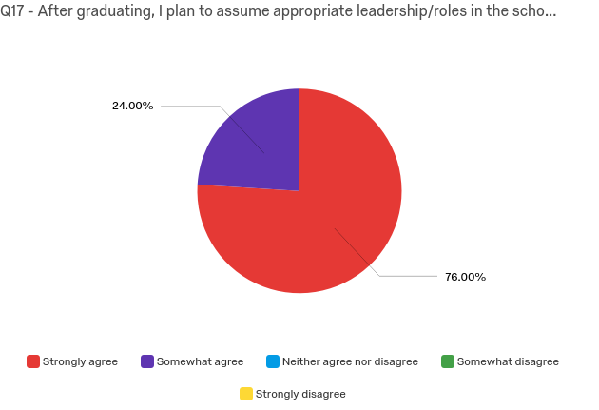

After graduating, I plan to be involved in internal or external communities that support student development.

Strongly agree | 76% | 19
Somewhat agree | 20% | 5
Neither agree nor disagree | 4% | 1
Somewhat disagree | 0% | 0
Strongly disagree | 0.% | 0
Total | 100% | 25

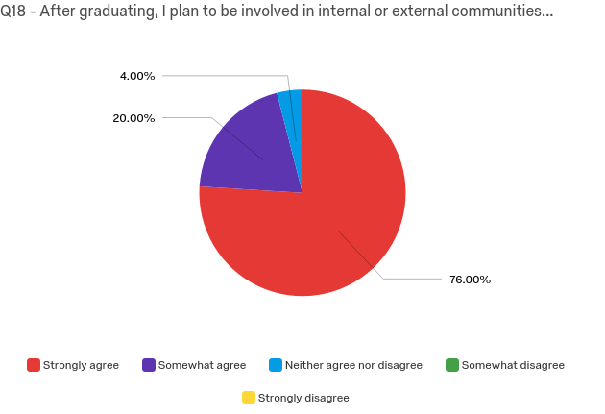

My training at Canisius stressed the importance of involving family and community members in a child's education.

Strongly agree | 92% | 23
Somewhat agree | 8% | 2
Neither agree nor disagree | 0% | 0
Somewhat disagree | 0% | 0
Strongly disagree | 0% | 0
Total | 100% | 25

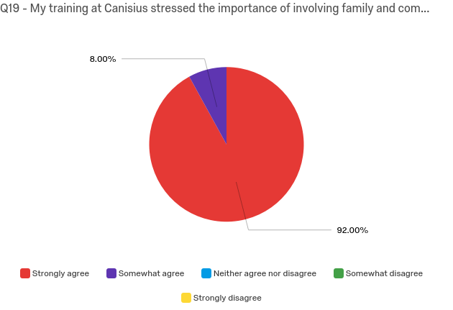

Professional Dispositions Please select the box that most closely describes your level of agreement.

Extremely professional | 88% | 22
Moderately professional | 12% | 3
Slightly professional | 0% | 0
Neither professional nor unprofessional | 0% | 0
Slightly unprofessional | 0% | 0
Moderately unprofessional | 0% | 0
Extremely unprofessional | 0% | 0
Total | 100% | 25

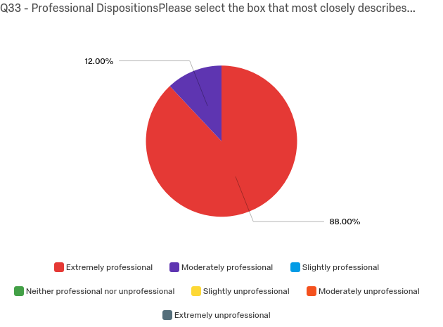
Based on my preparation at Canisius College I will be able to practice professional and ethical responsibility by respecting multiple perspectives of clients/students, local communities and colleagues.

Strongly agree | 92% | 23
Agree | 8% | 2
Somewhat agree | 0.% | 0
Neither agree nor disagree | 0% | 0
Somewhat disagree | 0% | 0
Disagree | 0% | 0
Strongly disagree | 0% | 0
Total | 100% | 25

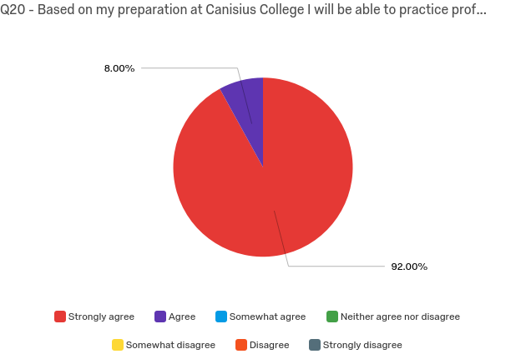

Based on my preparation at Canisius College I will be able to effectively communicate and work with clients/students, parents and other professionals.

Strongly agree | 80% | 20
Agree | 16% | 4
Somewhat agree | 4% | 1
Neither agree nor disagree | 0% | 0
Somewhat disagree | 0% | 0
Disagree | 0% | 0
Strongly disagree | 0% | 0
Total | 100% | 25

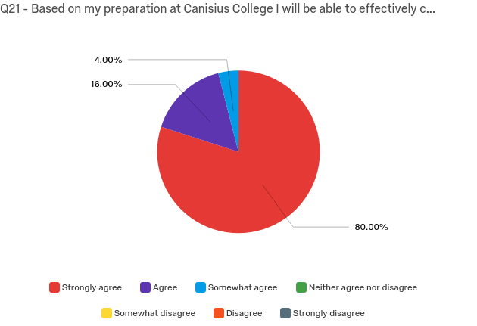

Based on my preparation I will be able to practice caring and fairness by using varied strategies and methods to address each client’s/students diverse needs the requirements of the task and the discipline.

Strongly agree | 80% | 20
Somewhat agree | 20% | 5
Neither agree nor disagree | 0% | 0
Somewhat disagree | 0% | 0
Strongly disagree | 0.% | 0
Total | 100% | 25

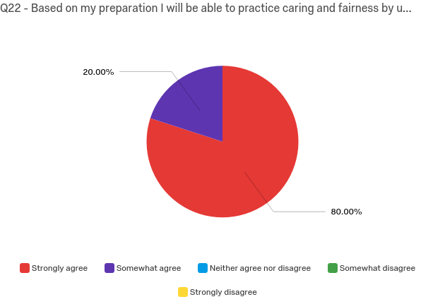

Based on my preparation I will act responsibly through collaboration with others as partners in planning and implementing effective programming.

Strongly agree | 92% | 23
Somewhat agree | 8% | 2
Neither agree nor disagree | 0% | 0
Somewhat disagree | 0% | 0
Strongly disagree | 0.% | 0
Total | 100% | 25

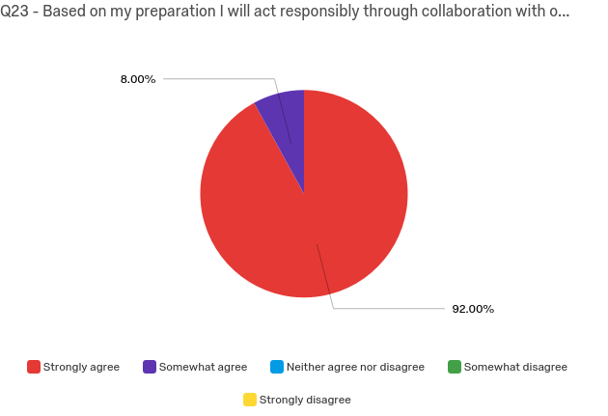

Canisius College provided me with the knowledge, skills and dispositions to be successful and to be recognized as a competent professional in my employment.

Strongly agree | 92% | 23
Somewhat agree | 8.% | 2
Neither agree nor disagree | 0% | 0
Somewhat disagree | 0% | 0
Strongly disagree | 0% | 0
Total | 100% | 25

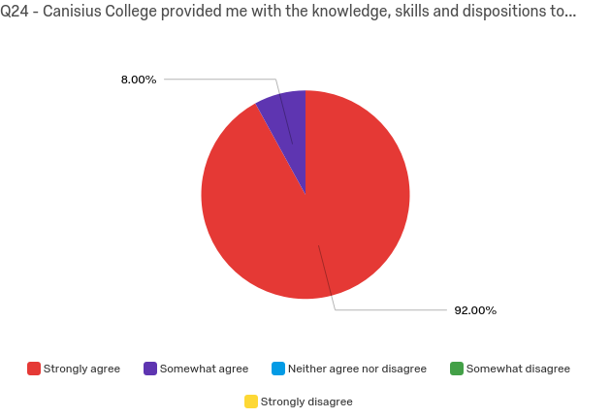

My preparation program at Canisius was well aligned to state requirements and national standards.

Strongly agree | 96% | 24
Somewhat agree | 4% | 1
Neither agree nor disagree | 0% | 0
Somewhat disagree | 0% | 0
Strongly disagree | 0% | 0
Total | 100% | 25

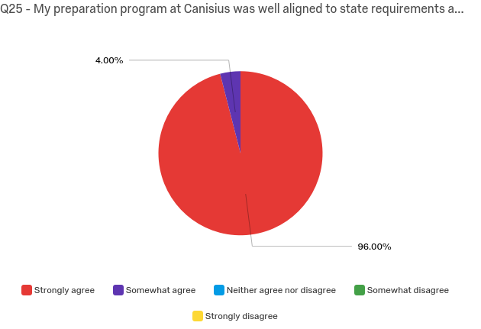

Please use the field below to send us your comments or thoughts regarding your experience at Canisius or post-Canisius. We welcome any opinions or suggestions related to our programs or the field of teacher education in general. Thank you SO MUCH for your time.

Please use the field below to send us your comments or thoughts regarding y...
The deaf education program is such a unique program that has given me an invaluable education and a job opportunity before graduation. To make this program larger you should work with speech language pathology programs at state schools like the university at buffalo to increase enrollment. Thank you for your support.
I feel that I am prepared to enter the real world of teaching and look forward for the opportunity to practice what I have learned in the field.
The Curriculum Center does not have class sets of books so it was difficult to take anything out.
Great experience
I really enjoyed my experience at Canisius College!
I really enjoy how our program provides us with experience early on in classrooms.
The values of the college are infused into the teacher education program and a major strength of the college. A suggestion would be to give more education on classroom management.
Great experience, teacher education program was excellent! Could not ask for a better teacher prep program.
I feel well prepared entering the teaching profession after my four years at Canisius.

Based on my preparation at Canisius College, I understand learning, teaching and/or other professional theoretical foundations.

UG Adolescence Ed (6)
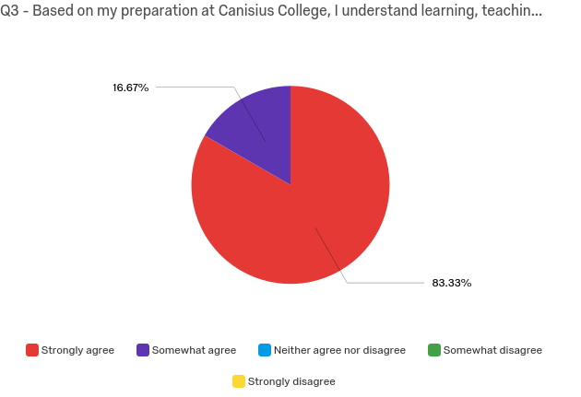

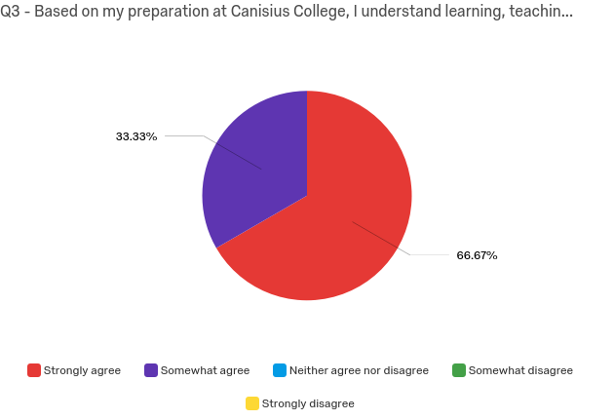
UG Early Child/Childhood Ed (3)

UG Physical Ed/Health Education (1)
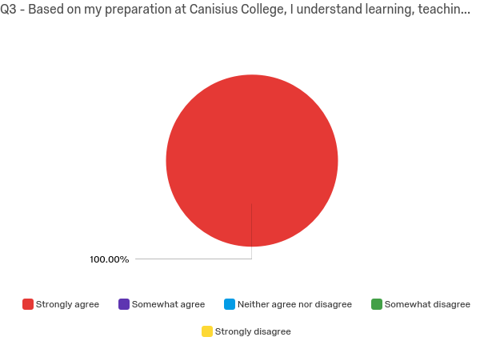
UG Childhood SPE (9)
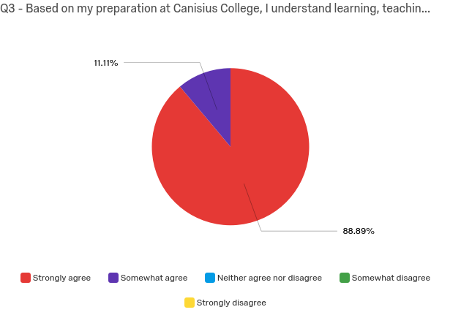
Gr Deaf Ed (3)

Graduate Physical Education (3)

Based on my preparation at Canisius College I can maintain appropriate classroom management.

UG Adolescence Ed (6)
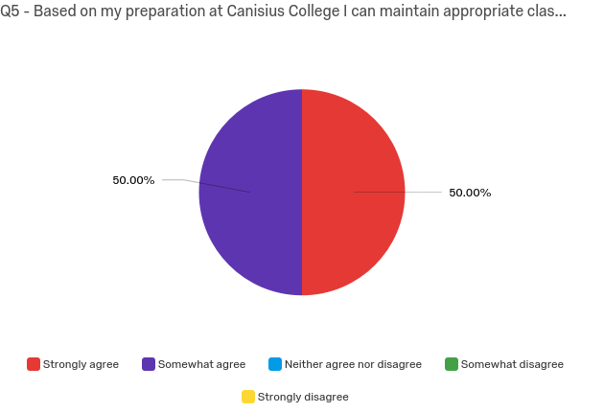
UG Early Child/Childhood Ed (3)
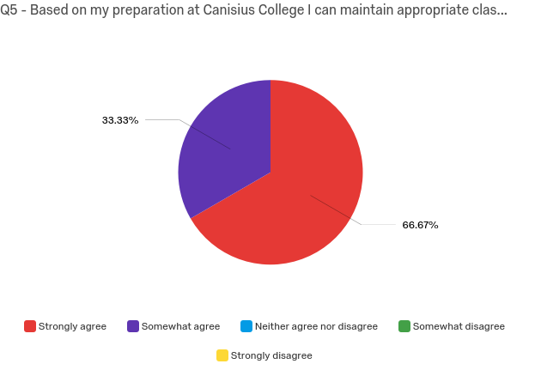
UG Physical Ed/Health Education (1)
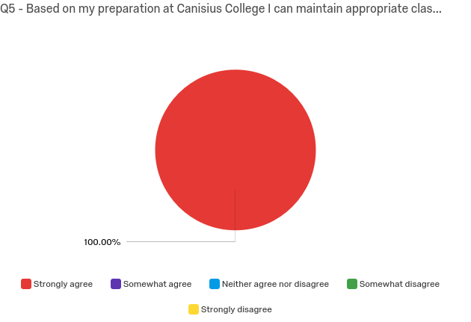
UG Childhood SPE (9)
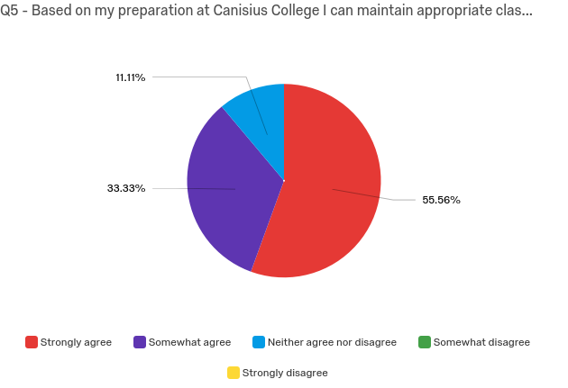
Gr Deaf Ed (3)
Graduate Physical Education (3)

I am able to employ strong knowledge in my content area.

UG Adolescence Ed (6)
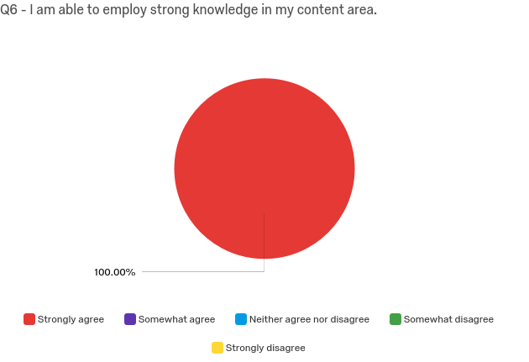
UG Early Child/Childhood Ed (3)
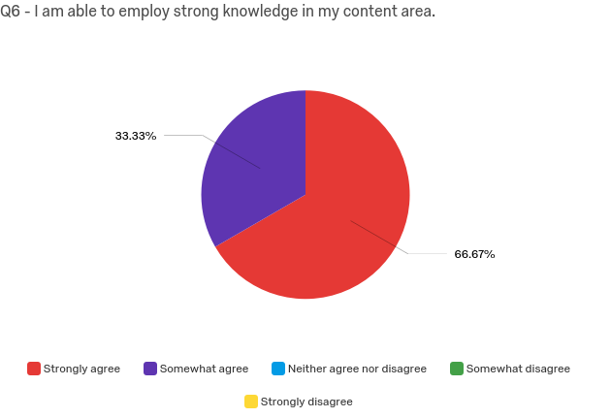
UG Physical Ed/Health Education (1)

UG Childhood SPE (9)
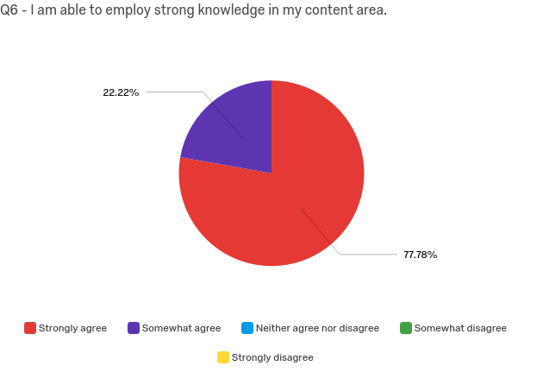
Gr Deaf Ed (3)
Graduate Physical Education (3)

I am able to employ appropriate pedagogical content knowledge.

UG Adolescence Ed (6)
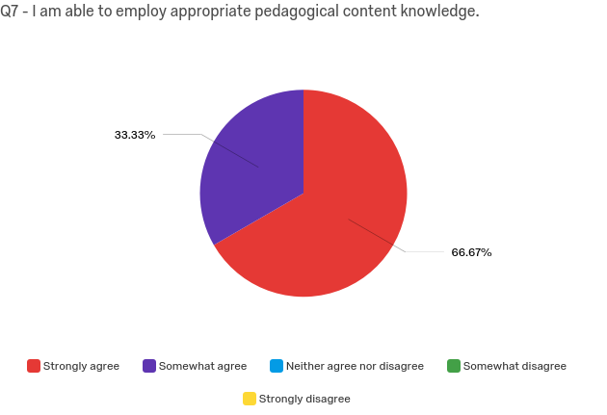
UG Early Child/Childhood Ed (3)
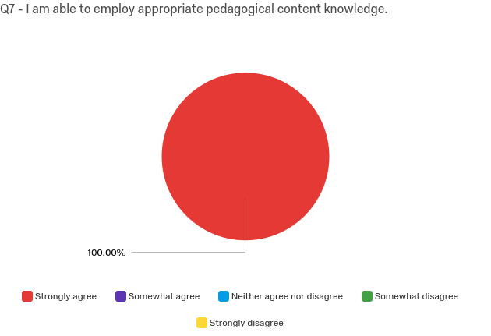

UG Physical Ed/Health Education (1)

UG Childhood SPE (9)
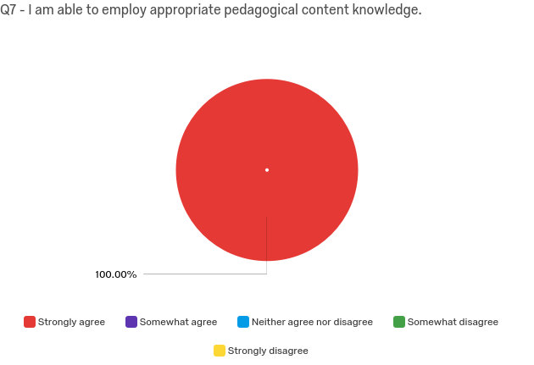
Gr Deaf Ed (3)

Graduate Physical Education (3)

Based on my preparation at Canisius College I am able to achieve positive outcomes regarding student learning, achievement and/or development.

UG Adolescence Ed (6)
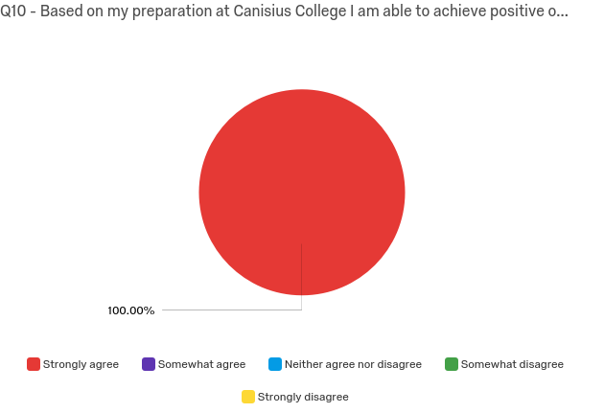
UG Early Child/Childhood Ed (3)
UG Physical Ed/Health Education (1)

UG Childhood SPE (9)
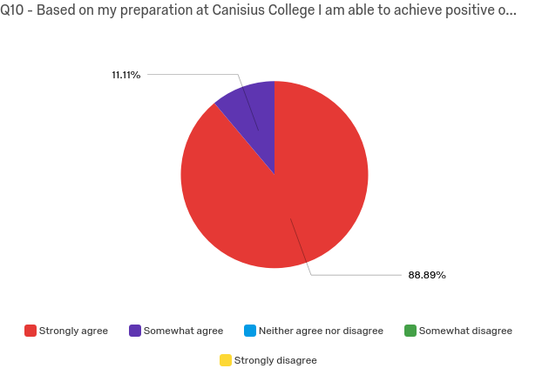
GR Deaf ED (3)
Graduate Physical Education (3)

Based on my preparation at Canisius College I can set clear learning goals and align instruction with standard based content.

UG Adolescence Ed (6)
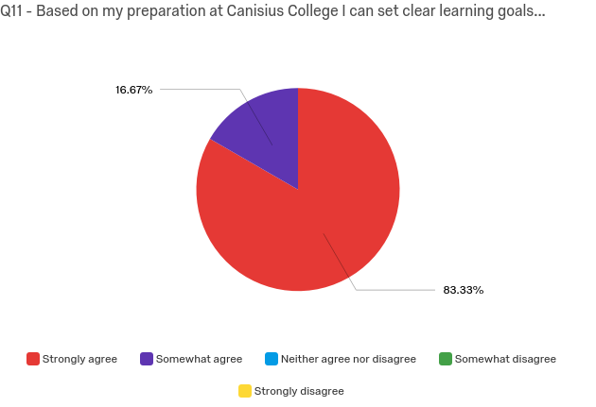
UG Early Child/Childhood Ed (3)
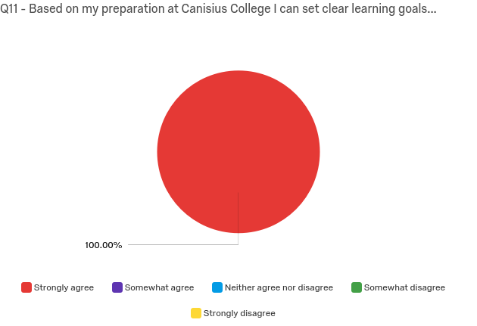
UG Physical Ed/Health Education (1)
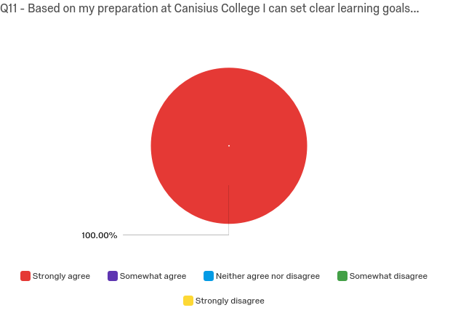

UG Childhood SPE (9)
Gr Deaf Ed (3)
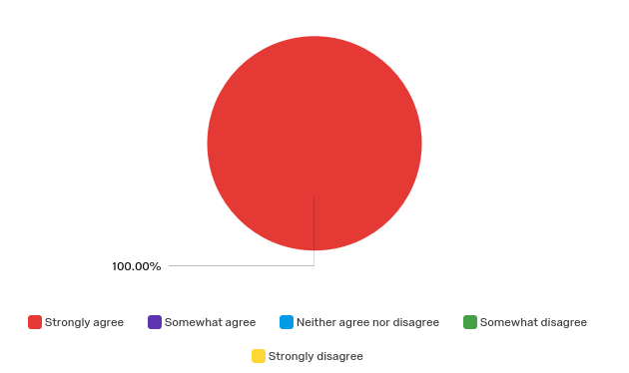

Graduate Physical Education (3)

Based on my preparation at Canisius College I can engage and motivate students.

UG Adolescence Ed (6)
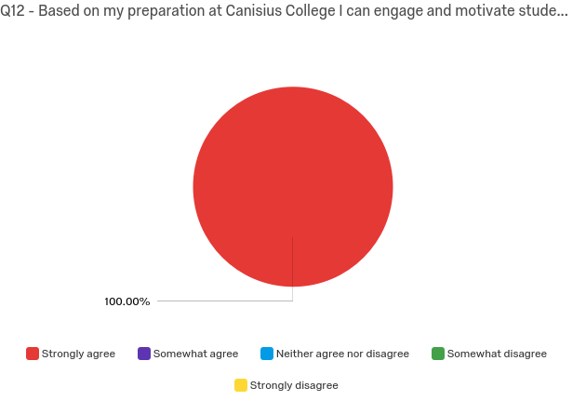
UG Early Child/Childhood Ed (3)
UG Physical Ed/Health Education (1)

UG Childhood SPE (9)
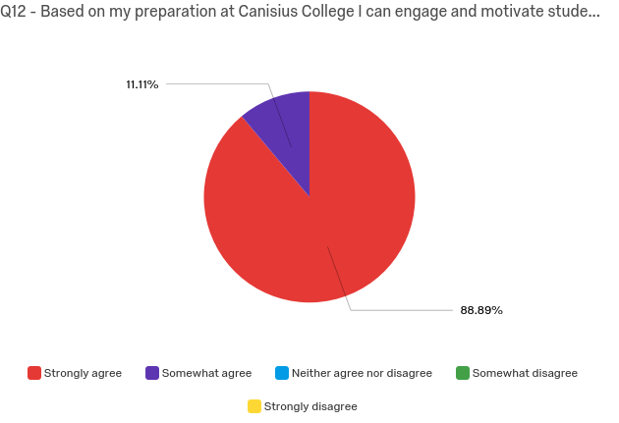
GR Deaf ED (3)

Graduate Physical Education (3)

I am able to successfully consider multiple ability levels in diverse P-12 settings when developing lessons and assessments.

UG Adolescence Ed (6)
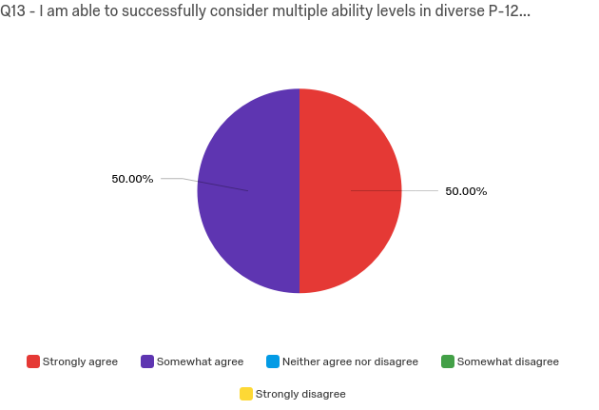
UG Early Child/Childhood Ed (3)
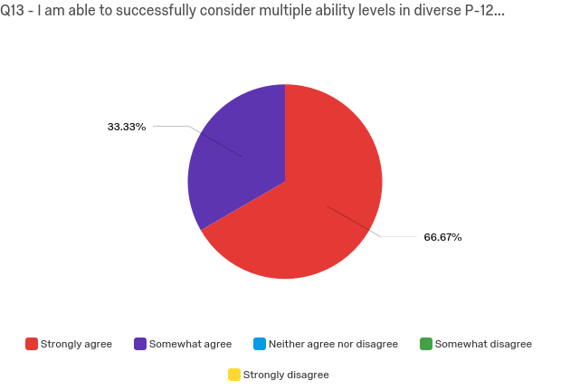
UG Physical Ed/Health Education (1)
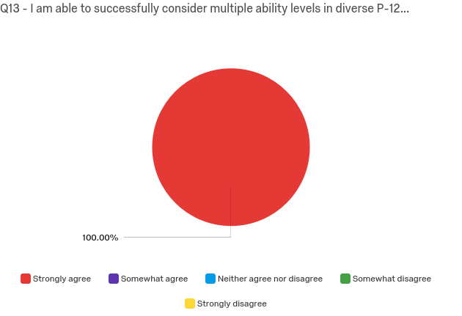
UG Childhood SPE (9)
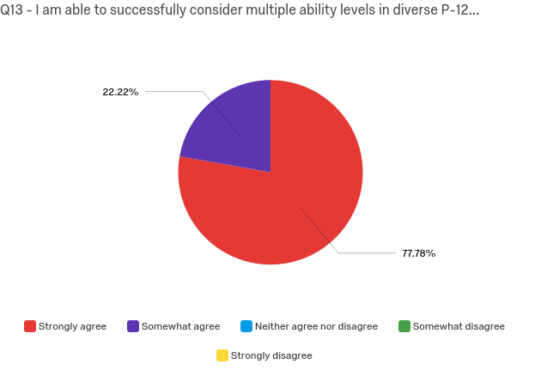
GR Deaf ED (3)
Graduate Physical Education (3)
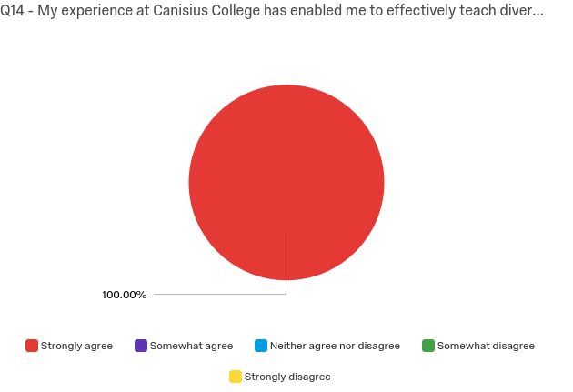
My experience at Canisius College has enabled me to effectively teach diverse P-12 student populations.

UG Adolescence Ed (6)
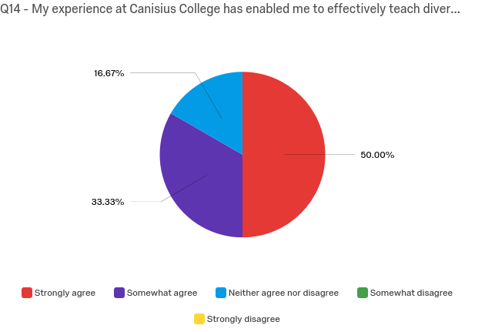
UG Early Child/Childhood Ed (3)
UG Physical Ed/Health Education (1)

UG Childhood SPE (9)
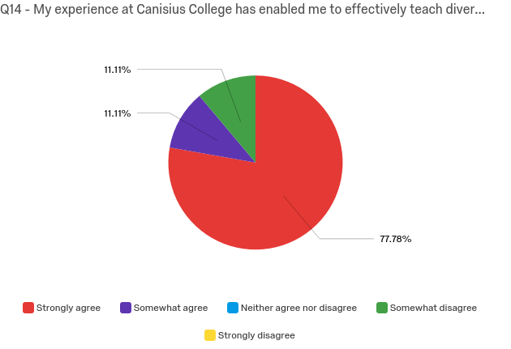
GR Deaf ED (3)
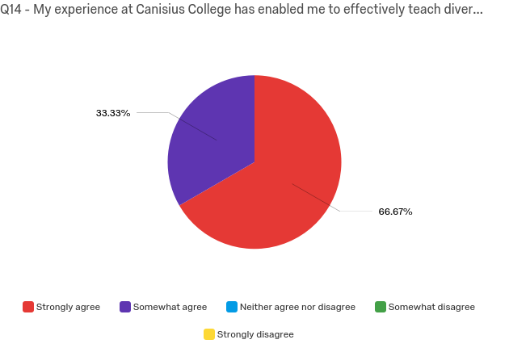
Graduate Physical Education (3)

I am willing and able to use the results of P-12 assessments of student learning to guide my instruction and/or professional effectiveness.

UG Adolescence Ed (6)
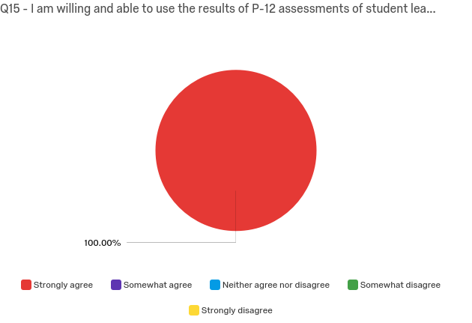
UG Early Child/Childhood Ed (3)
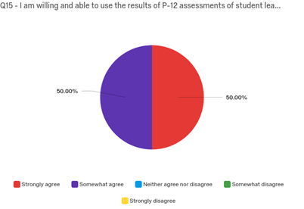
UG Physical Ed/Health Education (1)
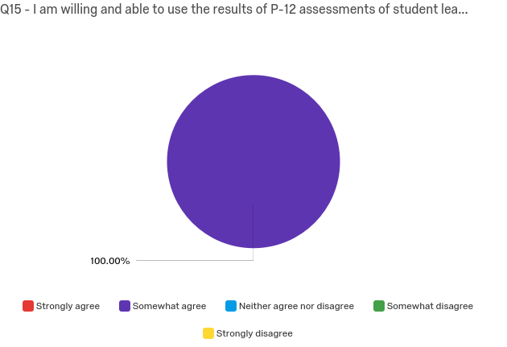

UG Childhood SPE (9)
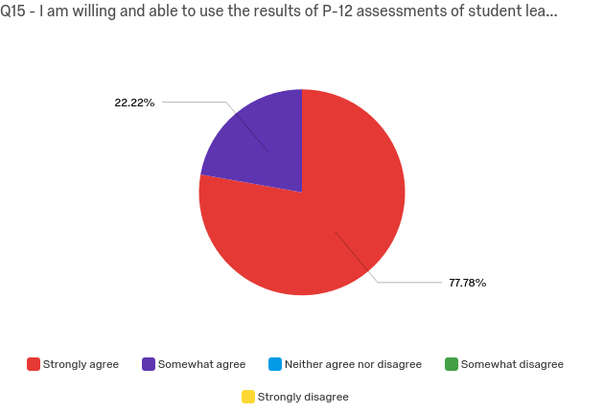
GR Deaf ED (3)
Graduate Physical Education (3)

I am willing and able to engage in collaboration to augment my professional practice.

UG Adolescence Ed (6)
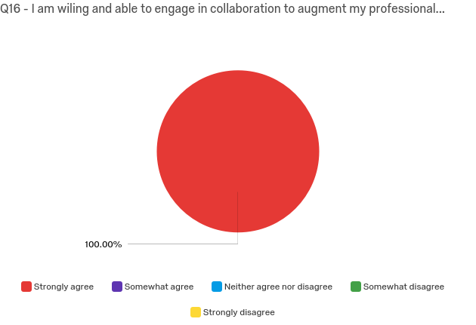
UG Early Child/Childhood Ed (3)
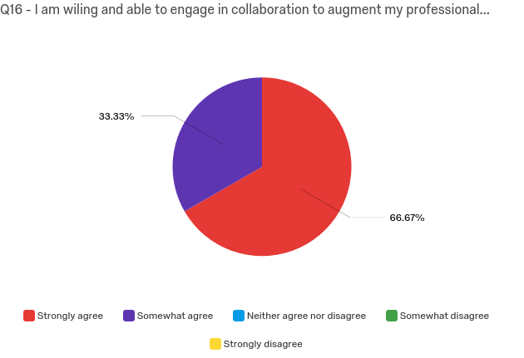
UG Physical Ed/Health Education (1)

UG Childhood SPE (9)
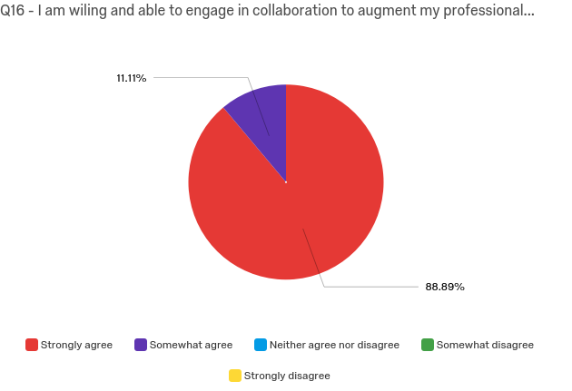
GR Deaf ED (3)
Graduate Physical Education (3)

After graduating, I plan to assume appropriate leadership/roles in the school and/or district.

UG Adolescence Ed (6)
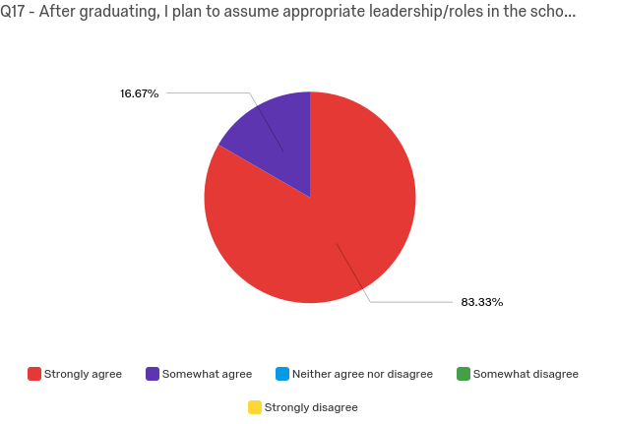
UG Early Child/Childhood Ed (3)
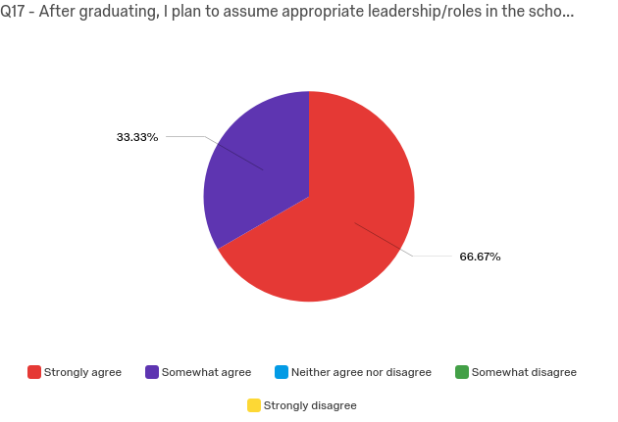
UG Physical Ed/Health Education (1)
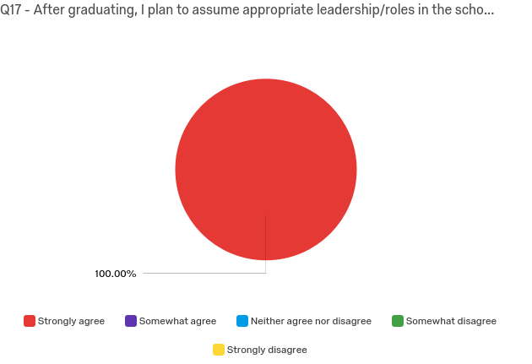

UG Childhood SPE (9)
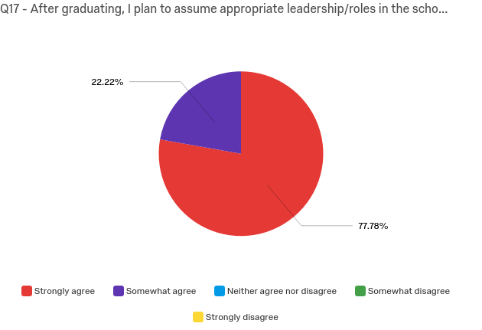
GR Deaf ED (3)
Graduate Physical Education (3)

After graduating, I plan to be involved in internal or external communities that support student development.

UG Adolescence Ed (6)
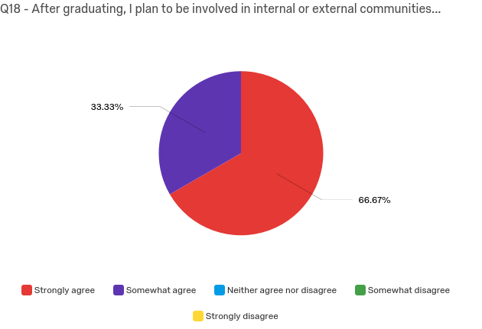
UG Early Child/Childhood Ed (3)
UG Physical Ed/Health Education (1)
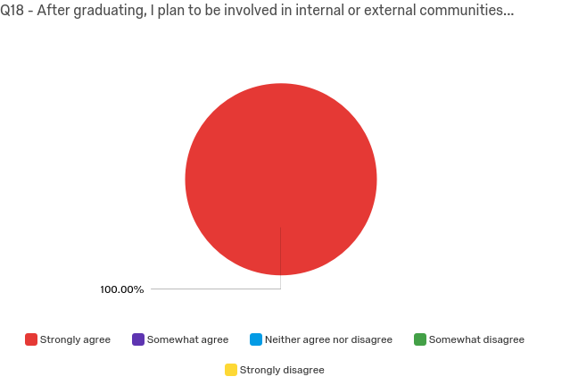

UG Childhood SPE (9)
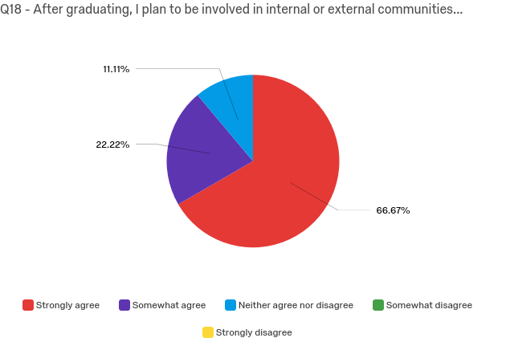
GR Deaf ED (3)
Graduate Physical Education (3)

My training at Canisius stressed the importance of involving family and community members in a child's education.

UG Adolescence Ed (6)
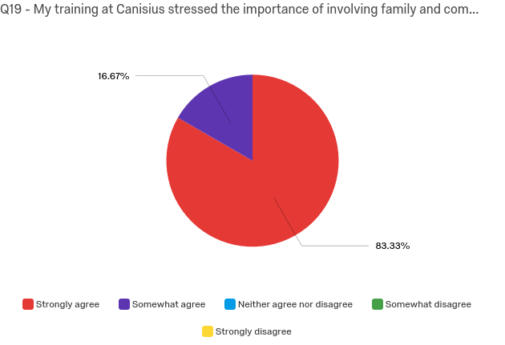
UG Early Child/Childhood Ed (3)
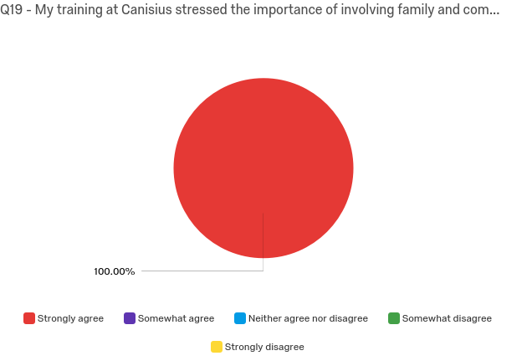
UG Physical Ed/Health Education (1)
UG Childhood SPE (9)
GR Deaf ED (3)
Graduate Physical Education (3)
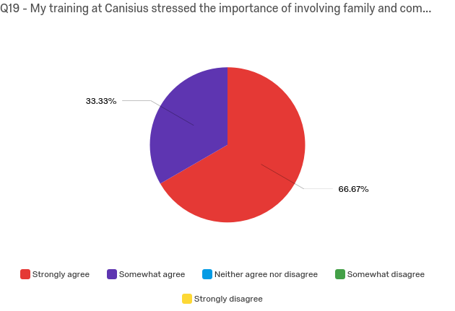

Professional Dispositions Please select the box that most closely describes your level of agreement.

UG Adolescence Ed (6)
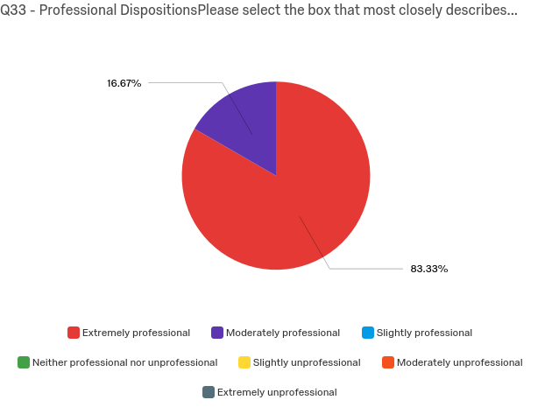
UG Early Child/Childhood Ed (3)
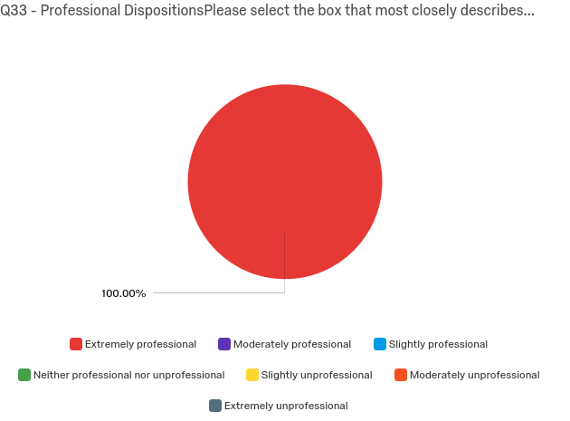
UG Physical Ed/Health Education (1)

UG Childhood SPE (9)
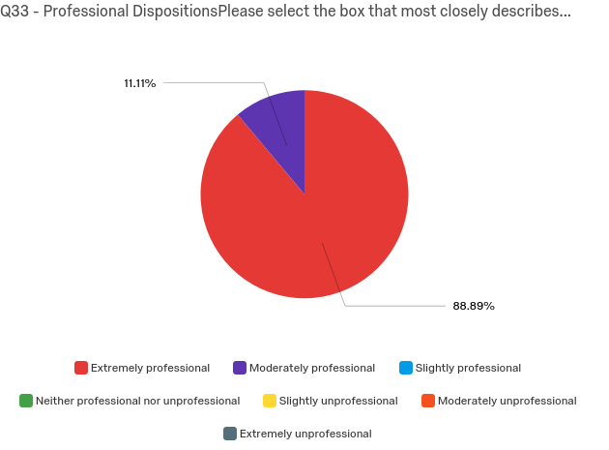
GR Deaf ED (3)
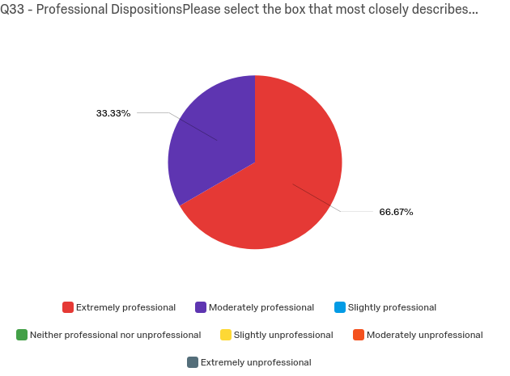
Graduate Physical Education (3)

Based on my preparation at Canisius College I will be able to practice professional and ethical responsibility by respecting multiple perspectives of clients/students, local communities and colleagues.

UG Adolescence Ed (6)
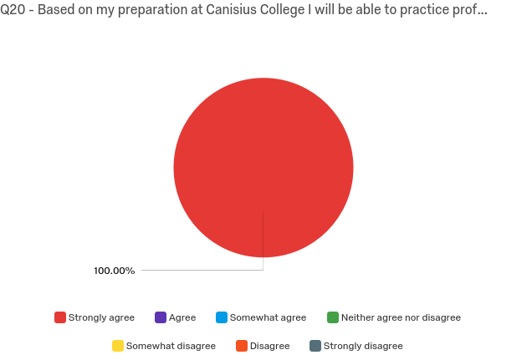
UG Early Child/Childhood Ed (3)
UG Physical Ed/Health Education (1)
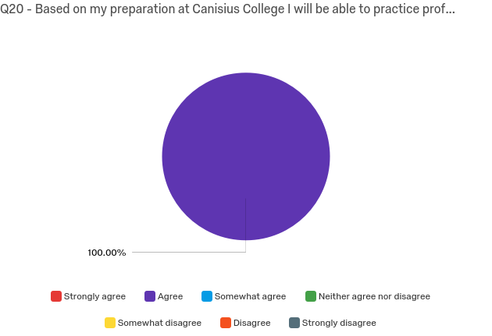

UG Childhood SPE (9)
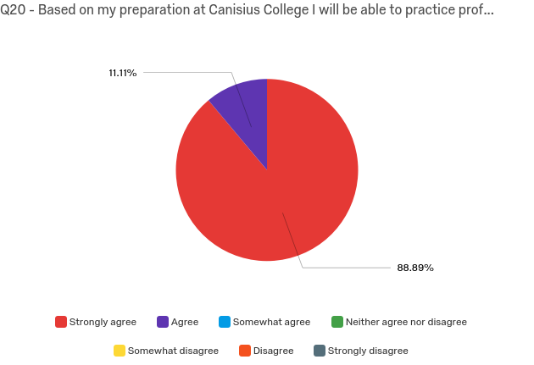
GR Deaf ED (3)
Graduate Physical Education (3)

Based on my preparation at Canisius College I will be able to effectively communicate and work with clients/students, parents and other professionals.

UG Adolescence Ed (6)
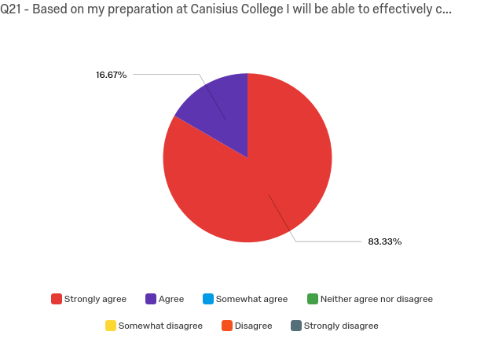
UG Early Child/Childhood Ed (3)
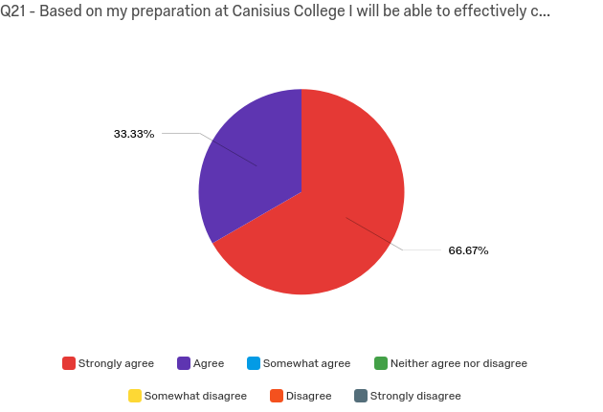
UG Physical Ed/Health Education (1)
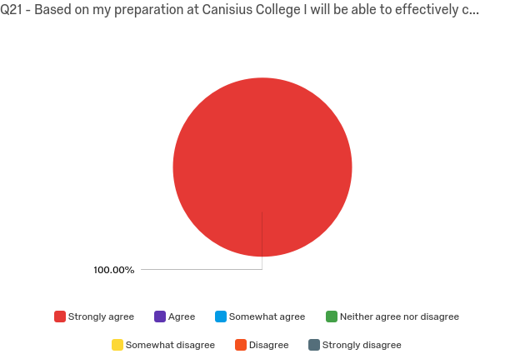

UG Childhood SPE (9)
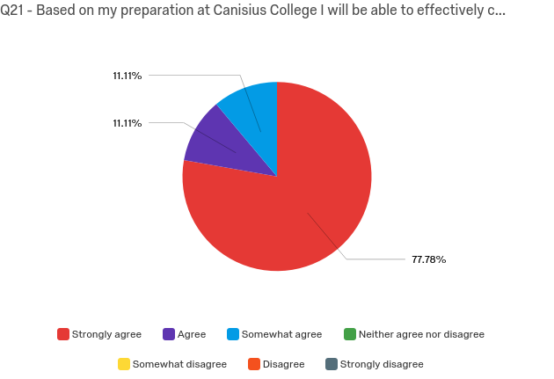
GR Deaf ED (3)
Graduate Physical Education (3)

Based on my preparation I will be able to practice caring and fairness by using varied strategies and methods to address each client’s /students diverse needs, the requirements of the task and the discipline.

UG Adolescence Ed (6)
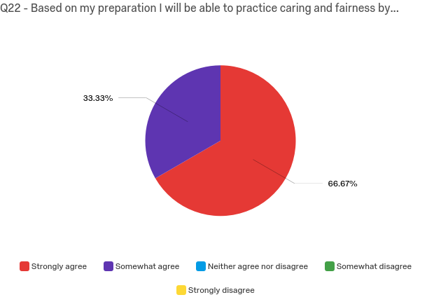
UG Early Child/Childhood Ed (3)
UG Physical Ed/Health Education (1)
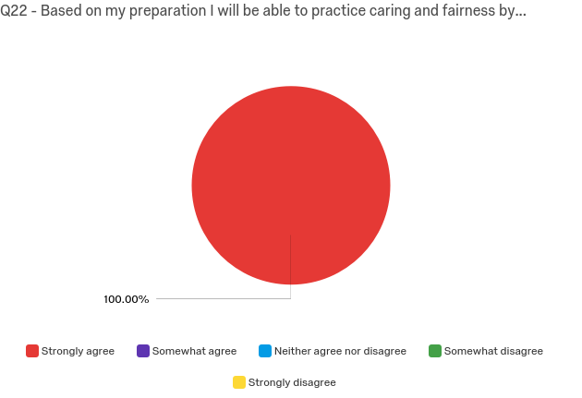

UG Childhood SPE (9)
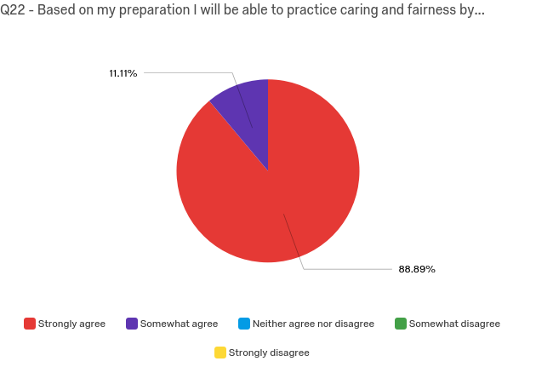
GR Deaf ED (3)
Graduate Physical Education (3)

Based on my preparation I will act responsibly through collaboration with others as partners in planning and implementing effective programming.

UG Adolescence Ed (6)
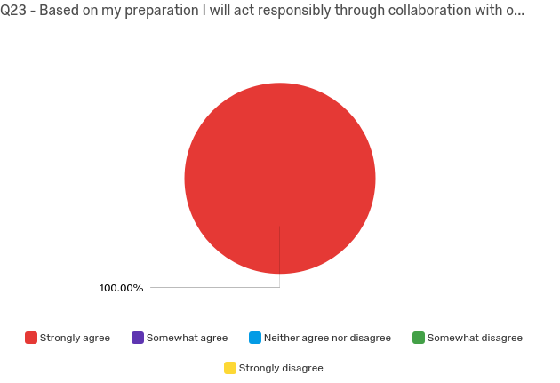
UG Early Child/Childhood Ed (3)
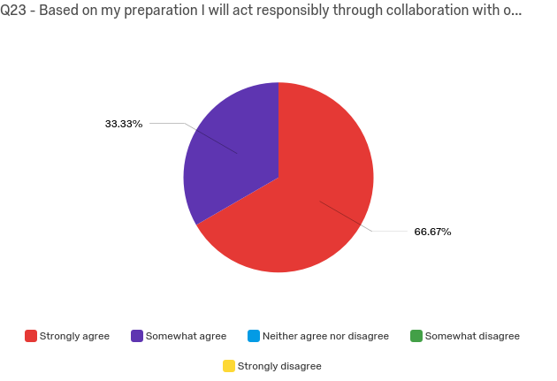
UG Physical Ed/Health Education (1)

UG Childhood SPE (9)
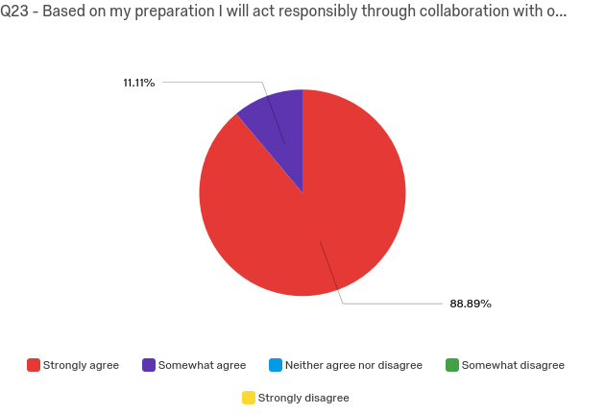
GR Deaf ED (3)
Graduate Physical Education (3)

Canisius College provided me with the knowledge, skills and dispositions to be successful and to be recognized as a competent professional in my employment.

UG Adolescence Ed (6)
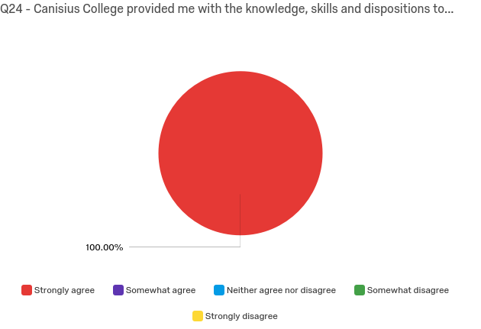
UG Early Child/Childhood Ed (3)
UG Physical Ed/Health Education (1)

UG Childhood SPE (9)
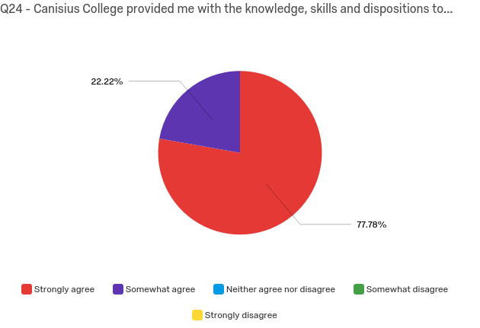
GR Deaf ED (3)
Graduate Physical Education (3)

My preparation program at Canisius was well aligned to state requirements and national standards.

UG Adolescence Ed (6)
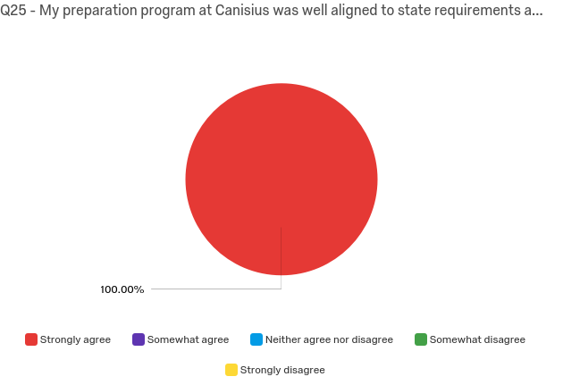
UG Early Child/Childhood Ed (3)
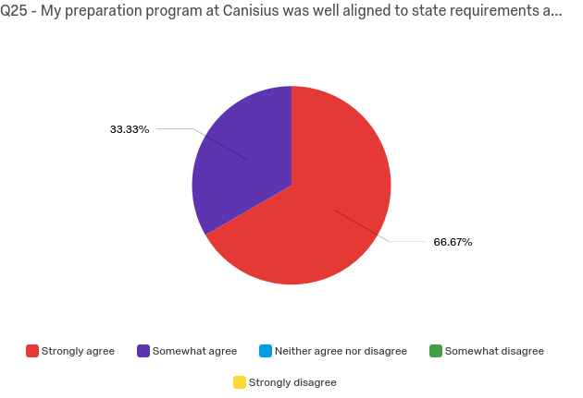
UG Physical Ed/Health Education (1)

25 out of 28 possible reesponses
UG Childhood SPE (9)
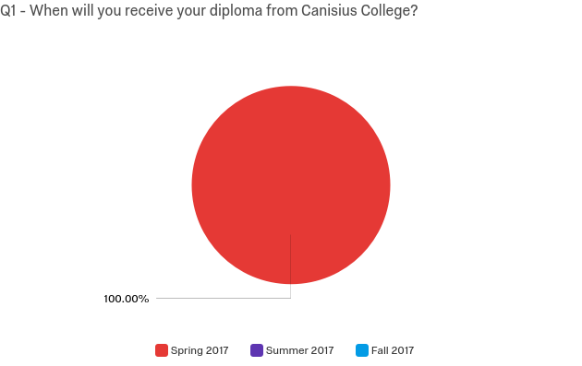
GR Deaf ED (3)
Graduate Physical Education (3)

